Answers

Task 1

- A call centre makes use of computer systems to handle phone calls. Label each of the devices below, then match each one to a likely way that it is used within the call centre.

Device |  | Use in the call centre
 |  | Used to enter notes of the conversation.
Device name: (Optical) mouse
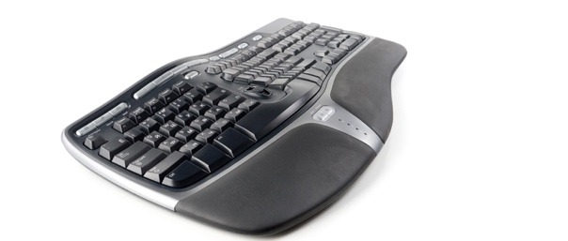 |  | Used for talking to callers that contact a call centre.
Device name: Keyboard
 |  | Used to select a button that will answer or end a call.
Device name: Microphone

Task 2
1. For this task you will need two devices. One device will make use of a real keyboard, whilst the other will need to be a laptop, smartphone or tablet that makes use of a virtual keyboard.
Work in a pair.
One partner should enter the following text using both keyboards. The other partner will record the results in the table below.
Enter the following text using each type of keyboard:
“Virtual keyboards allow users to enter text without the need for physical keys. They make use of a touchscreen to do this. As the screen displays the keys, alternative virtual keyboard views can be selected for characters such as & and #.”
 | Device one – physical keyboard | Device two – virtual keyboard

How long did it take to enter the text?

How many mistakes were made?

How easy was it to type using the keyboard? Think about comfort as well as efficiency and accuracy.
Answers will vary between students and their selected devices. Discuss with students why different input devices are used.
2. Discuss with your partner why different types of input device are used to enter text.
Key points include:
Physical keyboards are more efficient, especially for users who can touch type.
They are also less likely to give problems like repetitive strain injury.
However, physical keyboards are large.
Virtual keyboards allow for the same screen to be used for both displaying content and showing keys. Many different characters can be displayed on different virtual keyboard views.

Task 3
Research infra-red touch screens and make notes on your findings. In particular, focus on the following questions:
- What infra-red touch screen products are available?
- How does the technology work in the products you have found?
- Why is it more suitable than using resistive and capacitive?

Answers will depend on student research.
Students may like to focus on products that turn a large flat screen TV into a touch screen TV. This allows, for example, an 80” TV to be made into an interactive screen. Alternatively, there are products that have an integrated infra-red touch screen.
The technology works by having edges with infra-red LEDs and detectors. These fit onto the touch screen.
The advantages of this technique are that they can use existing/cheaper screens to convert them into touch screens. Unlike capacitive touchscreens, they will work even if wearing gloves, or a pointer is used.

